Dpg Institute of Technology And management

**Database Management System Project**

**SCHOOL MANAGEMENT SYSTEM**

**INDEX**

* About the project
* Tools Used
* ER-Diagram
* School Management System Details
* Queries to create School Management System
* Database Operations

**ABOUT THE PROJECT**

The School Management System is a database-based project done with help of Mysql. This project is very useful for the Schools to keep all the records of School. This project is multi-field project so that it can be modified for various purposes. The main aim of creating project on this topic is to show that Schools can use Structured Query languages to make their management system, This will also minimize the errors and also help the Schools to keep all the records related to Students and Teachers. There are many functions which can be performed in this management system and through the 6 tables which we have created the management can check the information regarding the students and also check the details about their fees and all. Teacher’s Department and all other information regarding teacher can also be checked easily. Various Queries can be used to perform multiple function in this School Management System.

**TOOLS USED**

Minimum Hardware Requirements:

I.OPERATING SYSTEM : Windows 7 (64-bit, Professional or higher)

II. PROCESSOR : Intel Core 2 Quad Q6600

III. Graphic Accelerators : Nvidia GT 710

IV. RAM : 8 GB

SOFTWARE REQUIRED:

MYSQL 8.0

**School Management System Detail**

**Tables Used-**

1. **Student**
2. **Classes**
3. **Fees**
4. **Attendance**
5. **Staff List**
6. **Teacher Department**

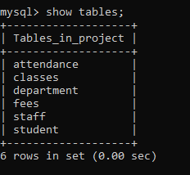

**ER DIAGRAM**

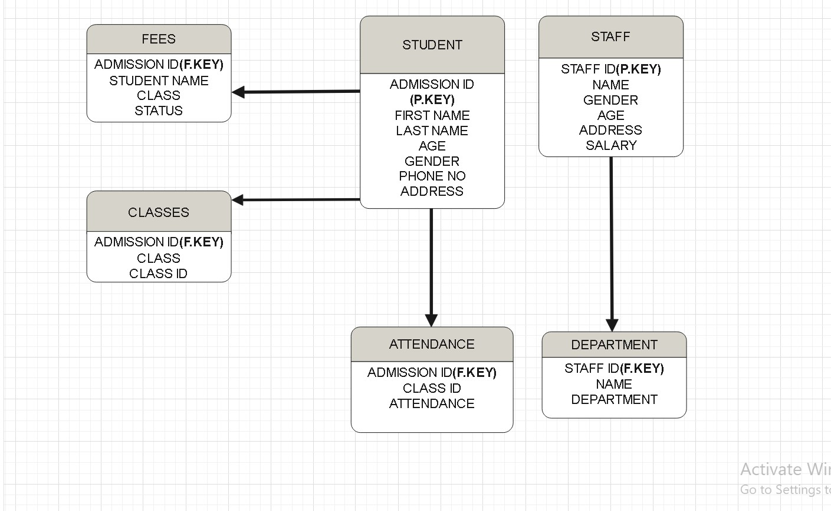

**QUERY USED TO CREATE THE DATABASE**

* **Student Table**

**Create Table**

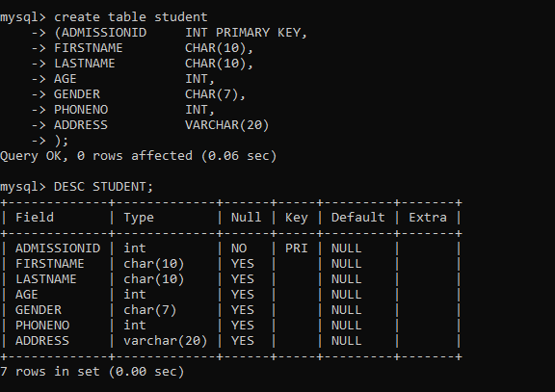

**Insert Data**

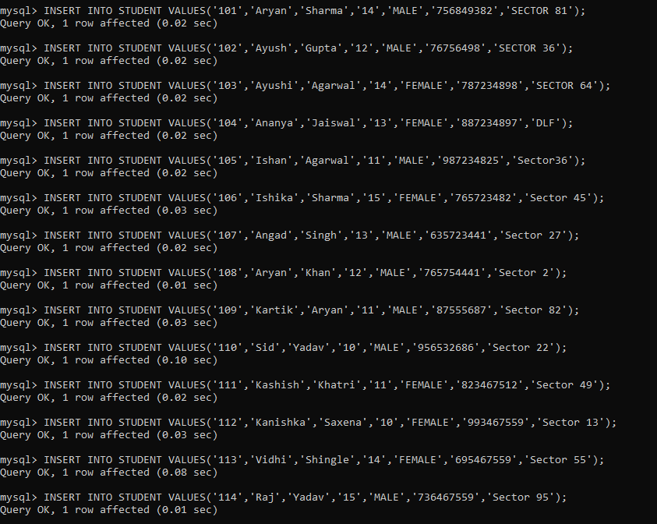

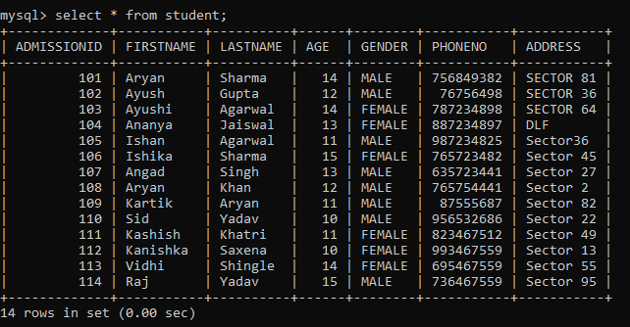

* **Classes Table**

**Create Table**

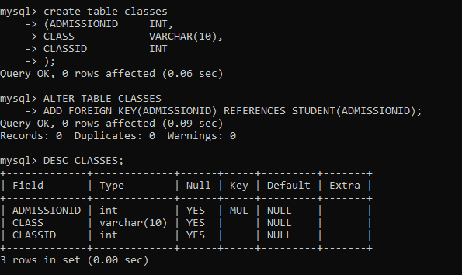

**Insert Data**

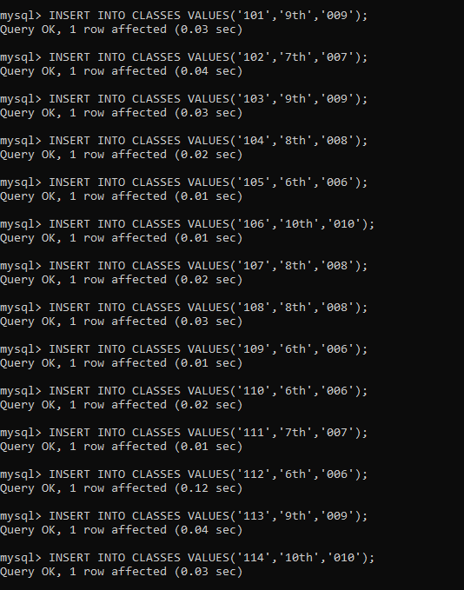

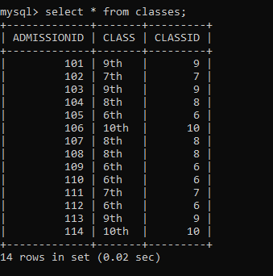

* **Attendance Table**

**Create Table**

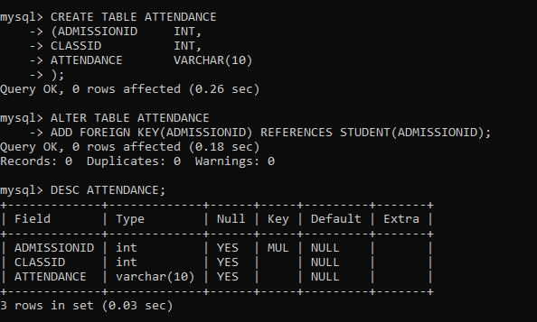

**Insert Data**

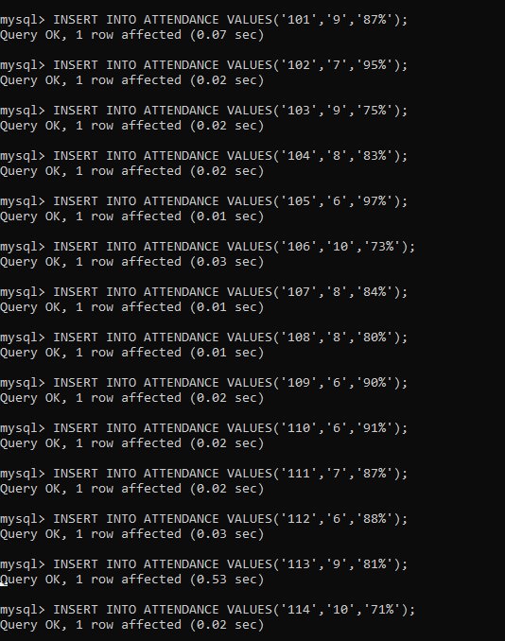

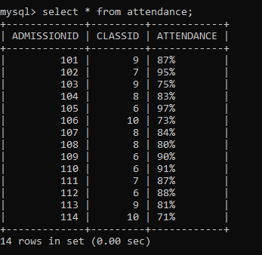

* **Fees Table**

**Create Table**

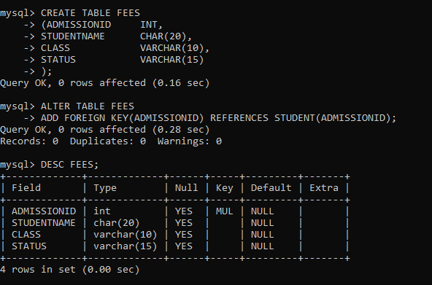

**Insert Data**

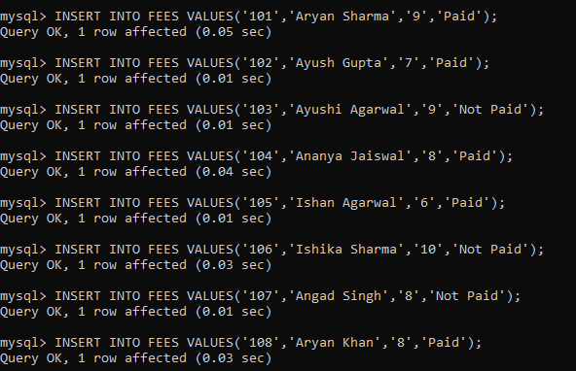

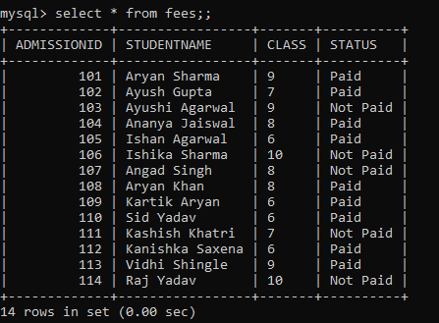

* **Staff Table**

**Create Table**

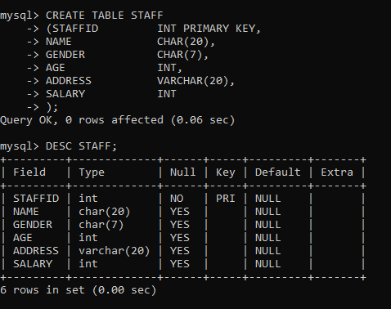

**Insert Data**

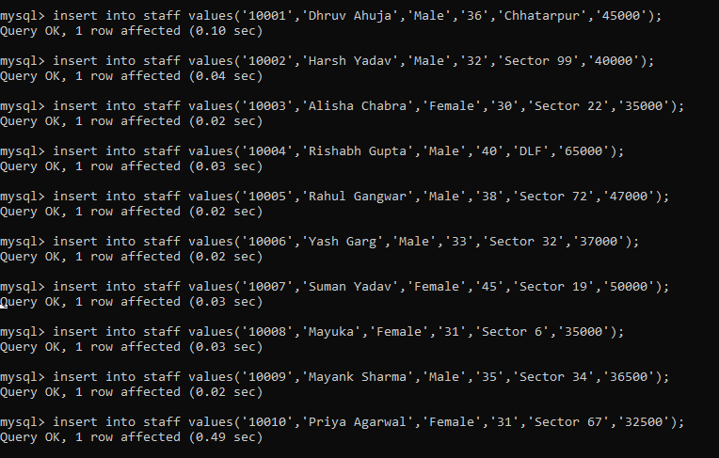

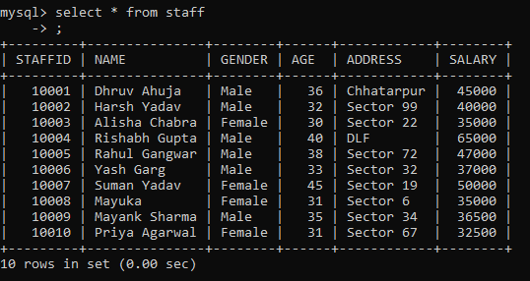

* **Department Table**

**Create Table**

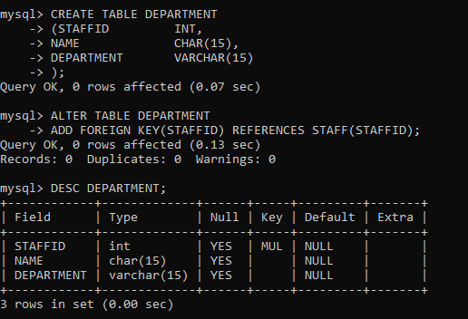

**Insert Data**

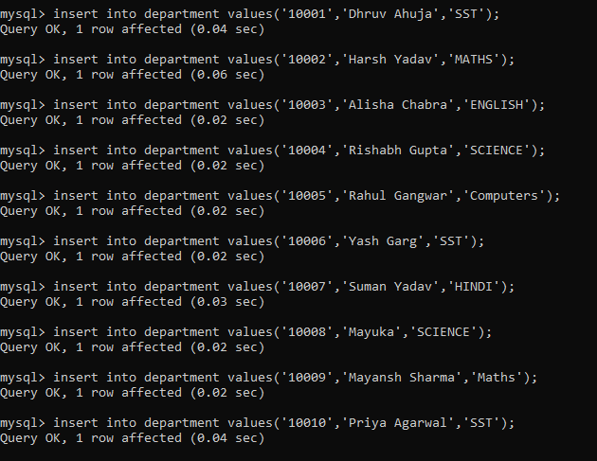

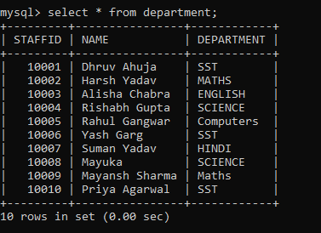

**Stored Database Query Operations :-**

**Q1. Query to Show the Total Admission.**



**Q2. Query to Show the Age of all the Students.**

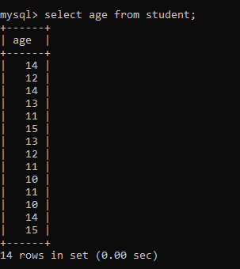

**Q3. Query to Show the Student having the highest attendance.**



**Q4. Query to show the students of a specific class.**

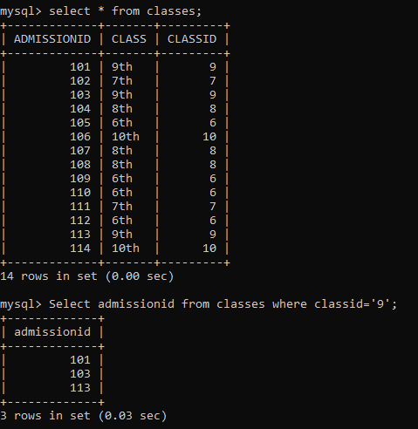

**Q5. Query to show the fee status of the students.**



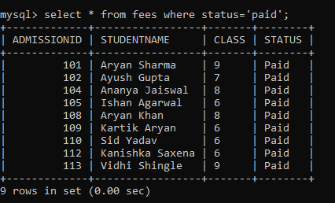**Q6. Query to show the fee status of students that has paid the fee.**

**Q7. Query to show the detail about female teachers in the School.**

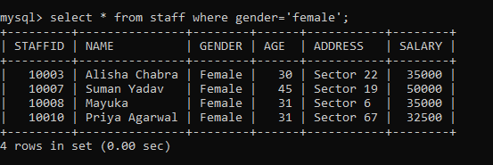

**Q8. Query to insert details about new student.**

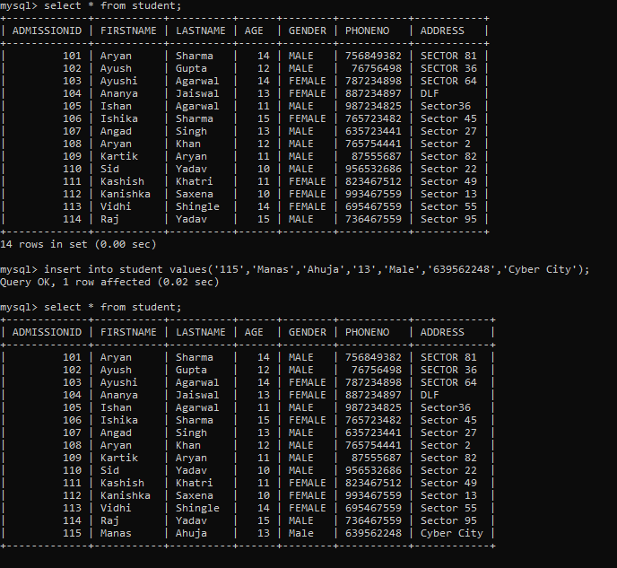

**Q9. Query to check teachers of certain department.**

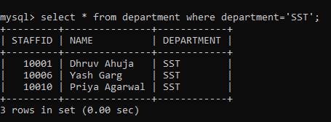

**Q10. Query to change the department of a teacher.**



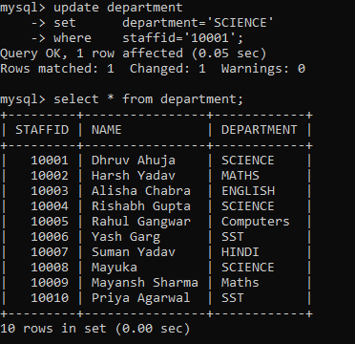

**Q11. Query to select the students whose name start from A.**

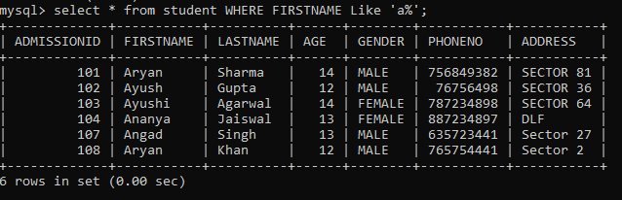

**Q11. Query to select the student whose attendance lies between 85% and 92%.**

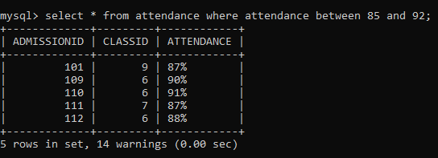

**Q12. Query to select the student of certain age.**

